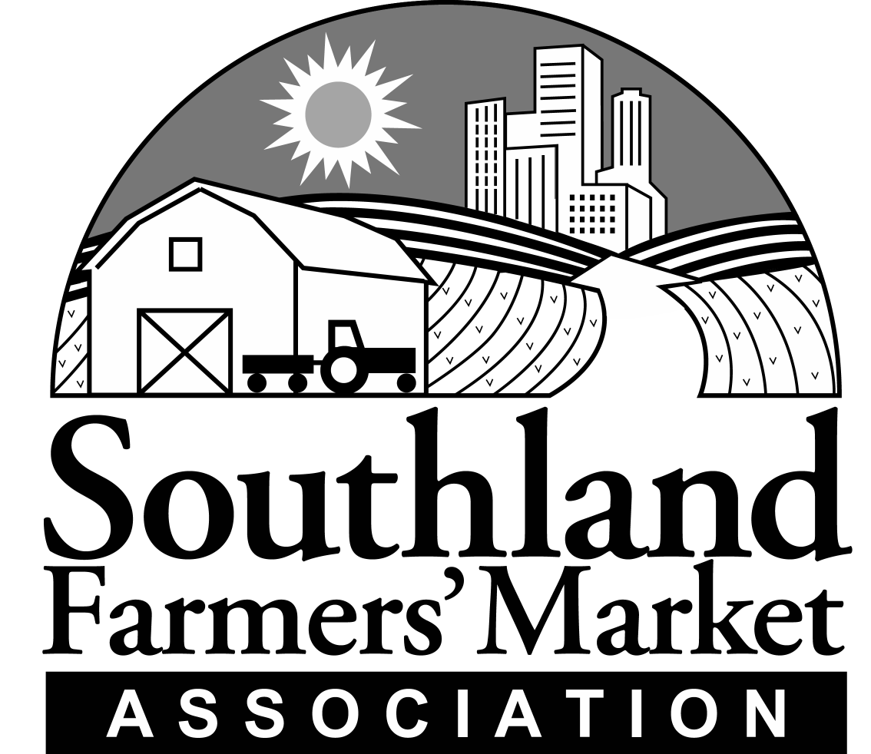Regular Meeting of the Board of Directors
M I N U T E S
Sunday, June 5, 2005
2:30 p.m. – 5:30 p.m.
Memorial Park
Santa Monica, California

Members Present: Tom Archibald, Laura Avery, Vince Bernard, Scott Beylik, Harry Brown-Hiegel, Mary Hillebrecht, Tim Monahan, Dennis Peitso, Jeanne Stehly, Polly Ward, Alex Weiser, Gail Zannon
Members Excused: David Avila, Romeo Coleman, Gene Etheridge, Armando Garcia, Phil McGrath, Bob Polito
Also Present: Howell Tumlin, Stacy Brown, Aaron Epstein, Anne Epstein, Laura Spensley

Item 1. Call To Order
President Laura Avery called the regular meeting of the Southland Farmers’ Market Association Board of Directors to order at 2:45 p.m. in the Community Room at Memorial Park, 1401 Olympic Blvd. Santa Monica, California.
Item 2. Roll Call
Howell conducted a roll call of the Southland Board members. A quorum was present.
Item 3. Approval of Agenda
The agenda was presented. A MOTION was MADE, SECONDED and CARRIED to AMEND the agenda to add an opportunity for public comment by Aaron Epstein and a presentation by Scott Beylik on an upcoming CACASA meeting in Sacramento as Item 6.5 on the Agenda. A Motion was MADE, SECONDED and CARRIED to APPROVE the agenda as amended.
Item 3.5 Approval of Minutes
a. Minutes of the January 16, 2005 meeting of the Board of Directors were submitted for approval. A MOTION was MADE, SECONDED and CARRIED to approve the minutes as submitted.
Item 4. President’s Report
Laura Avery reported that a great deal has happened since the last Board meeting. One important issue is that Southland is facing financial difficulties. The difficulties are caused by the lost of revenues from some markets. The Board will be talking today about how to keep Southland in operation during these difficult times. Southland has accomplished what we set out to do last year. We have started new markets, established a 501(c)(3) foundation, and we have new categories of membership. We are continuing to transition to greater independence and away from reliance on market fees.
The Southland/Santa Monica Audit Program is going well. We have received positive comments from growers about the program. We will continue to schedule two growers a month.
We will work to have a representative from the Tree Fruit Agreement come and tour the markets. He is a friend of the markets and very helpful to us. Our commitment to enforcement and integrity remains strong.
Item 5. Committee Reports
a. Executive Committee – has met six times since the last Board meeting. The Committee has spent a good deal of time dealing with market membership agreements. The Board reviewed the minutes of the Executive Committee meetings.
Item 6. Executive Director’s Report
Howell reported the most important developments would be discussed later in the agenda. We have a number of new markets and new market disputes to go over. We have successfully initiated the Southland/Santa Monica Audit program as a first step towards effective enforcement in the markets. We recently began producing a new weekly publication called “Market Reports” that goes out to Southland member markets each week. We ask the markets to copy it and distribute it to the growers. We have been following the Los Angeles Street Closure and Special Event Permit proposal that would impose fees on certified farmers’ markets in the City of Los Angeles. There will be a hearing on this matter before the Transportation Committee next Wednesday. Southland has taken the position that only certified farmers’ markets in which 75% of the vendors are farmers should be eligible for a fee waiver. We had a successful Annual Meeting, to the credit of the Annual Meeting Committee.
We continue to be an organization in transition to a future of operating new markets while still relying on the revenues from member markets. Some of these markets desire to leave the Association. The loss of these markets places Southland under a serious financial strain.
Gene Etheridge has been elected as the Chair of the CFMAC. We are glad that he is willing to serve. The CFMAC is taking up a number of important issues this year including what noncertifiable ag products and prepared foods will or will not be allowed in a certified farmers’ market, what non-ag products will be allowed to be sold near a certified farmers’ market, and future funding for the certified farmers’ market program. Southland continues to play a leadership role in representing the interests of growers at the CFMAC.
6.5 Public Comment
Aaron Epstein commented that Southland should be present at City of Los Angeles Committee hearings if it wants to be viewed as a leader among certified farmers’ markets. He felt that Southland must be present if we truly want to be seen as a representative of the growers on issues of importance to them. Howell assured the Board that he would be present to represent Southland at the City of Los Angeles Committee meetings in the future.
Scott Beylik reported that the Finance Committee of the CFMAC is dealing with funding of the Certified Farmers’ Market Program. The $.60 per market day fee does not cover the expenses of the certified farmers’ market program. Over the last few years, the State has not been allocating all of its expenses to the certified farmers’ market program. CDFA is now requiring that the program pay for itself. Consequently, either the $.60 fee will have to be raised or the program will be forced to scale back.
The Ag Commissioners have proposed several changes to the certified farmers’ market program. They have formed a task force to work on major reforms. They are now ready to meet with the CFMAC to discuss these changes. The first meeting between CFMAC and the CACASA will be on Monday, June 6, 2005. Scott Beylik and Gene Etheridge will be at the meeting. Mary Hillebrecht expressed concern that one of the Commissioners’ proposals is to eliminate nursery stock from the list of certifiable Ag products. Tim Monahan mentioned that there would be fewer false complaints by growers if they were required to put up a deposit whenever they file a claim against another grower. The deposit would only be returned if the claim were found to have merit.
Scott Beylik reported that the Ag Commissioners are making these proposals because they see Southland as an organization that they can work with to reform the farmers’ market program. It is significant that the Ag Commissioners are now willing to talk about how to make the certified farmers’ market program work as it was intended. The program will surely change in the next couple of years. Southland needs to stay focused on what it wants to change to benefit growers and work with the Commissioners to see it done.
Item 7. Financial Reports
Howell presented the 2004 Year End Report and the First Quarter 2005 Report. Southland has experienced a loss of revenues this year. Even though we have cut expenditures considerably, Southland had to run a deficit for the winter months of 2004-05. The Association will operate within the revenues it receives for the summer months, but it cannot build an adequate reserve for the coming winter. Staff has reduced its salaries by 20% and has lowered the Association’s overhead. We have deferred expenditures where it is possible. We have renegotiated contracts to reduce expenses. Meanwhile revenues for the first quarter of 2005 are 40% less than the same period in 2004. Southland is consequently only able to hold its own by deferring expenses and building up a considerable debt. We will need to find new sources of revenue or face further reductions in staff time and expense.
Item 8. Staff Reports
a. Panorama City Certified Farmers’ Market – Southland opened the Panorama City Certified Farmers’ Market on May 20, 2005. The market began with 16 growers but sales have been disappointing. By the third week, only nine growers were in the market. Almost half of the sales are WIC checks. This market is likely to struggle along for some time. It is not clear when, or if, it will be self-supporting. The VEDC is handling the promotions for the market. Southland is being reimbursed for its expenses in this market. We will have to decide week-to-week on whether to continue the market and see how it develops.
b. Kaiser Permanente Fontana – Harry reported that this market is unique. The market is on the campus of the Kaiser Permanente Medical Center in Fontana. It opened on May 27, 2005. The market is being held every two weeks. There were nine growers at the opening with sales of $4,200. It has been something of a surprise at how well the market did on opening day. The hospital staff is enthusiastic and the market was well planned. All seems to be going very well.
c. Kaiser Permanente Markets – Howell reported that we are in conversation with three other Kaiser Permanente Hospitals that want certified farmers’ markets at their locations. This is an opportunity for Southland to partner with a large regional organization to provide produce only markets on a scale that works well for the staff of the facilities.
d. Studio City Farmers’ Market – Howell reported that a mediation hearing would take place in the next few weeks with representatives of the Studio City Farmers’ Market. The issue that is in dispute is whether the market will conduct a legitimate vote of the growers on continuing its membership in Southland.
e. Los Angeles Unified School District -- LAUSD has issued a Request for Qualifications for an organization to organize and operate 8 markets in each school district. The Board discussed Southland’s participation in this project. A MOTION was MADE, SECONDED and CARRIED that Southland will submit a proposal to the LAUSD to open markets on high school properties.
f. Raising Funds for Southland – The new opportunities bring with them the challenge of finding the funding to pay for opening so many new markets. Laura discussed holding a workday at a nearby farm and charging a fee to raise money for Southland. Scott suggested sending a letter to the membership to ask them to donate.
9. Action Items –
a. Election of Officers – The Board elected Laura Avery as President, Scott Beylik as Vice President, Gail Zannon as Treasurer and Vince Bernard as Secretary. The elections were by acclamation.
b. Committee Elections – The Board elected the following members to Board Committees:
1. Finance Committee – Chair Gail Zannon, Dennis Peitso, Tom Archibald, Scott Beylik, Harry Brown-Hiegel and Polly Ward
2. Nominating Committee – Chair Mary Hillebrecht, Jeanne Stehly, Scott Beylik, Alex Weiss, Gene Etheridge, Romeo Coleman, and Armando Garcia.
3. Annual Meeting Committee – Chair Polly Ward, Jeanne Stehly, Anne Epstein, Phil McGrath, and Tim Monahan.
4. Personnel Committee – Chair Tim Monahan, Gail Zannon, Harry Brown-Hiegel, Scott Beylik, and Mary Hillebrecht.
5. Membership Committee – Chair Harry Brown-Hiegel, Alex Weiser, Armando Garcia, Romeo Coleman, Mary Hillebrecht, and Vince Bernard.
6. Legislative Committee – Chair Scott Beylik, Phil McGrath, Dennis Peitso, Alex Weiser, Tim Monahan, Gene Etheridge, Vince Bernard, and Armando Garcia.
c. Schedule of Future Board Meetings – The Board selected the following dates for the 2005-06 Board of Directors meetings:
July 24, 2005
October 23, 2005
January 22, 2006
April 30, 2006

10. Adjournment -- There being no further business, the Board adjourned at 5:30 PM.

